6115-MAHENDRA INSTITUTE OF ENGINEERING AND TECHNOLOGY

*NOISE POLLUTION MONITORING*

TEAM: PROJ_223288_TEAM_1

Team id: 570

Year: III

|  |
| --- |
| Team Members Name  YASVANTHRAJ.S  VIGNESHWARAN.M  VIGNESH.J  TAMIL SELVAN.A.D  SURESH.D  SURENDIRA BABU.D  Mentor Name  M.SANTHANARAJ |

IoT Innovation in Noise Pollution Monitoring

* Learn about the revolutionary IoT innovation in noise pollution monitoring and why it's important for the world today. Noise pollution refers to the excessive or disruptive noise that can harm human health and disturb the natural balance of ecosystems.
* As urban areas grow and industrial activities expand, noise pollution becomes a critical concern. By leveraging the power of IoT, we can effectively monitor and manage noise levels to create healthier and more livable environments.
* Looking for strategies to deal with the never-ending cacophony of urban life? Are you interested in learning how the Internet of Things (IoT) can change real-time noise pollution monitoring in cities?
* Cities can now monitor noise pollution in real time thanks to the seamless integration of IoT devices, opening up a plethora of options.

Importance of Monitoring Noise Pollution

* It is important to monitor noise pollution to assess its impact on the community and the surrounding environment. Accurate data on the levels of noise pollution can help regulatory authorities enforce noise limits. Monitoring the noise levels can also help identify sources of noise pollution and develop mitigation measures.

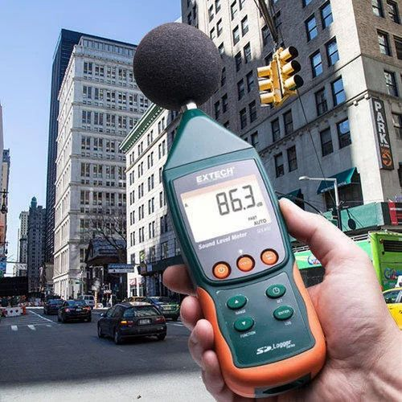

Challenges in Monitoring Noise Pollution

1. Costly Traditional Monitoring Methods

* The traditional noise monitoring methods involve the installation of static noise sensors, which can be costly and

ineffective in remote areas or areas with irregular sound patterns.

1. Data Accuracy

* The accuracy of the collected data might be questionable, giving misleading information and hindering the noise pollution control efforts of regulatory agencies and communities.

1. Limited Accessibility

* Noise data cannot be easily accessible to the public leading to a lack of transparency and citizen participation in monitoring environmental noise pollution.

IoT Innovation in Noise Pollution Monitoring

|  |  |
| --- | --- |
| IoT sensors: | Adoption of IoT sensors that analyze sound frequency and intensity, which can be used to capture and analyze environmental noise pollution data. |
| Real-time Access: | IoT devices can provide real-time access to noise pollution data on a webserver enabling the concerned stakeholders to access the data and take necessary actions promptly. |
| Predictive Analytics: | The noise pollution data collected via IoT can be further analyzed utilizing predictive analytics to estimate the future pattern of the noise levels. |
| Low-Cost Monitoring: | IoT sensors are significantly less expensive when compared to static monitoring devices thereby offering cost-effective monitoring solutions to individuals and communities. |

Effects of Noise Pollution

* Noise pollution has far-reaching consequences on both human health and the environment. Prolonged exposure to high noise levels can lead to hearing loss, cardiovascular problems, and mental health issues.Additionally, wildlife and ecosystems can be disrupted, affecting the behavior, communication, and survival of various species.

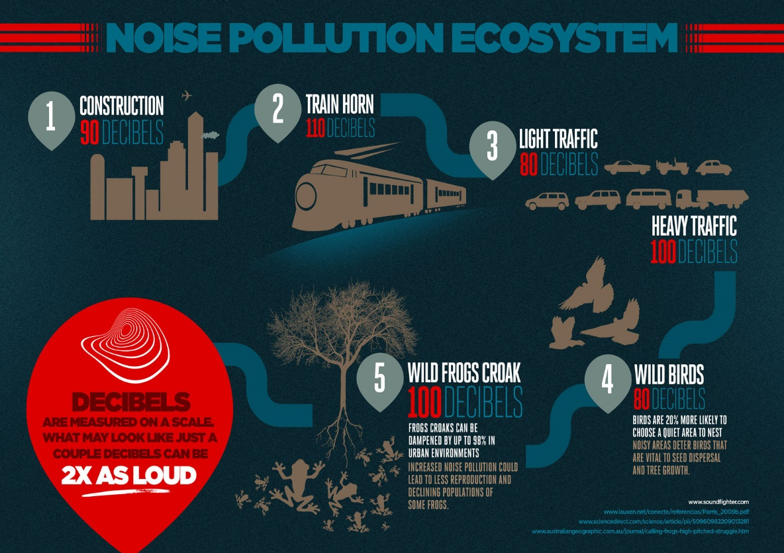

Internet of Things (IoT) and its Potential for Noise Pollution Monitoring

* IoT technology enables the connection and communication of various devices, sensors, and systems through the internet. Leveraging this connectivity, we can develop smart solutions for noise pollution monitoring and control.
* By deploying IoT devices with built-in noise sensors, we can collect real-time data on noise levels and patterns across different locations.This data can be analyzed and visualized to gain insights, identify noise hotspots, and inform effective mitigation strategies

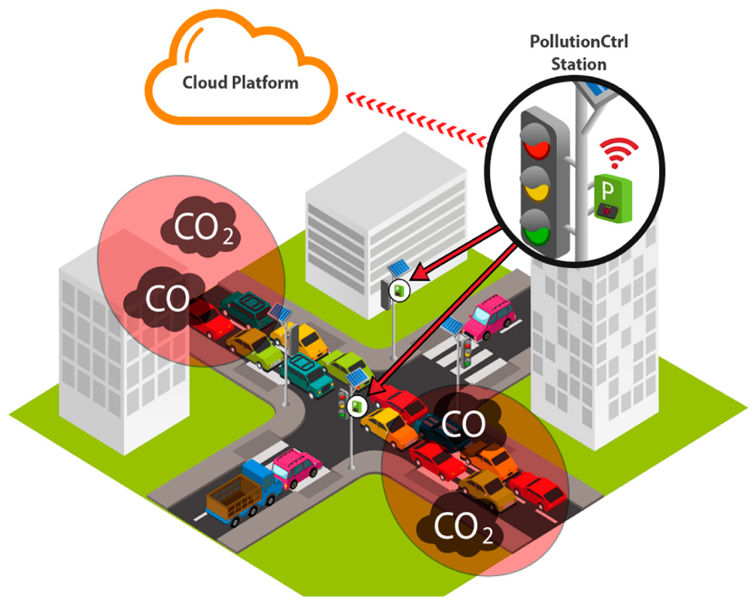

Objectives of the Program

1. Reducing Noise Pollution

We aim to reduce noise pollution levels by collecting and analyzing data on ambient noise levels and identifying areas where noise levels exceed the recommended limits.

1. Protecting Public Health

Our program aims to protect public health by reducing the impact of noise pollution on the human body. We hope to create a healthier and more productive environment.

1. Promoting Awareness and Education

Our program aims to promote awareness and education on noise pollution, its causes, and its consequences. We hope to educate people on the dangers of noise pollution and ways to reduce it.

How IoT Devices Enable Real-Time Noise Monitoring

* IoT devices, equipped with sound sensors and connectivity features, can be strategically deployed throughout urban areas to monitor noise levels continuously. These devices capture audio data and transmit it to a central system for analysis.
* The data can then be processed in real-time to assess noise patterns, identify hotspots, and trigger alerts or notifications when noise levels exceed predefined thresholds. This enables authorities to respond promptly, implement noise reduction measures, and create quieter and more livable urban environments.

|  |
| --- |
| THANK YOU |